
AMERICAN INTERNATIONAL UNIVERSITY–BANGLADESH
Faculty of Science & Technology (FST)
Department of Computer Science
OBJECT ORIENTED PROGRAMMING 2
FINAL TERM PROJECT
GoMart Application
Retail Billing & Inventory Management System

Submission Information | Details
Group Name | Team GoMart
Section | AA
Semester | Summer 2025-2026
Submitted To | Dr. Md Iftekharul Mobin
Student Name | Nawrin Parvin Adita
Student ID | 24-56038-1
Email | Nawrinparvinadita@gamil.com____________________________
Group Member | Maisha Jannat Monzur (22-47624-2)
Contribution | 50% of the group implementation

Individual Project Submission & Contribution Report

Table of Contents
1. Student & Project Information
2. Project Overview
3. GitHub & Repository Documentation
4. Individual Code Contribution
5. Database Contribution
6. GUI / Windows Forms Evidence
7. System Architecture & Diagrams
8. Testing & Run Verification
9. Academic Integrity & AI Disclosure
10. Declaration
Appendix — Submission Checklist

1. Student & Project Information
Item | Information
Student | Nawrin Parvin Adita
Student ID | 24-56038-1
Email | To be added
Section | AA
Course | Object Oriented Programming 2
Project | GoMart Application
Domain | Retail Billing & Inventory Management System
Group Name | Team GoMart
Group Members | Maisha Jannat Monzur (22-47624-2); Nawrin Parvin Adita (24-56038-1)
Number of Members | 2
Individual Contribution | 50%

1.1 Contribution Split
Member | Contribution | Main Implementation Areas
Maisha Jannat Monzur | 50% | Login, Main Menu, Category, Product
Nawrin Parvin Adita | 50% | Seller, Admin, Selling/Billing, About
Shared work: database integration, DBConnect.cs, project configuration, SQL/database resources, testing, integration of the modules, documentation and final repository organization were treated as shared group work.

2. Project Overview
GoMart Application is a Windows desktop-based retail billing and inventory management system developed for a small retail-store environment. It uses C# Windows Forms for the user interface, ADO.NET for database communication, and Microsoft SQL Server for persistent storage.
The application supports two roles, Admin and Seller. Administrators can manage categories, products, users and selling functions, while sellers are focused on the selling/billing workflow.

2.1 Main Objectives
- Provide role-based login for Admin and Seller users.
- Provide category and product CRUD functionality.
- Provide seller and administrator management.
- Provide a billing interface with order-total calculation.
- Store billing records in Microsoft SQL Server.
- Use a straightforward relational database structure.
- Provide a practical Windows Forms interface for a small retail store.

2.2 Scope
- Single-store, single-database desktop application.
- Admin and Seller roles.
- Category-to-product management.
- Cash-style billing and bill history.
- Online store, barcode scanning, multi-currency, payment gateway, tax/discount engine and advanced dashboards are outside the current scope.

3. GitHub & Repository Documentation
The project is maintained as a public GitHub repository. The repository contains the application package, README, database resources, SQL setup script, diagrams and application screenshots.
Repository Item | Location / Status
README | README.md at repository root
Application | GoMartApplication.zip
Database | Database/GoMartDatabase.bacpac
SQL setup | Database/SQL_DB/GoMartDB_SQLServer_Setup.sql
ER diagram | Documentation/Diagrams/ER_Diagram.png
Architecture | Documentation/Diagrams/System_Architecture.png
Login flow | Documentation/Diagrams/Login_Role_Flow.png
GUI screenshots | Documentation/Screenshots/
Individual report | Documentation/Report/

3.1 GitHub Evidence Fields
The project contribution percentage is set at 50% for each member as agreed for this submission. GitHub commit count, dates and commit URLs should be copied from the live repository history rather than guessed.
Field | Value
GitHub username | nawrinparvinadita
Contribution | 50%
Commit total | 4
Group-agreed role | 50% implementation contribution

4. Individual Code Contribution
Nawrin Parvin Adita contributed approximately one half of the implementation work. The split was organized by functional modules so that each member had clear ownership while shared integration remained a joint responsibility.
File / Class | Responsibility
frmAddNewSeller.cs | Seller account management and CRUD
AddAdmin.cs | Administrator account management and CRUD
SellingForm.cs | Point-of-sale billing, order total and bill saving
AboutBox1.cs | Application About information

4.1 Code Distribution
The distribution below is intended to show the functional ownership of the application code. Designer and resource files associated with each form follow the same ownership as the main .cs file.
- Nawrin — frmAddNewSeller.cs: seller management.
- Nawrin — AddAdmin.cs: administrator management.
- Nawrin — SellingForm.cs: point-of-sale billing and bill saving.
- Nawrin — AboutBox1.cs: About information.
- Maisha — Form1.cs: login, role selection and authentication flow.
- Maisha — frmMain.cs: home screen and role-based menu navigation.
- Maisha — frmCategory.cs: category CRUD and duplicate-category handling.
- Maisha — AddProduct.cs: product CRUD, validation, category selection and search/filtering.
- Shared — DBConnect.cs, Program.cs, App.config, SQL/database files, project integration and testing.

4.2 Non-Trivial Implementation Explanation
My main implementation responsibility in GoMart was the staff-management and billing side of the application. I worked on the seller management form for creating, updating, deleting and listing seller accounts, including duplicate-name checks. I also worked on the administrator management form for maintaining admin records and validating duplicate administrator IDs. Another major part of my contribution was the SellingForm, which provides the point-of-sale workflow. It lets the user search products by category, select a product, enter a quantity, add the item to the current order, calculate the running grand total, and save the completed bill through the database procedure used by the project. I also maintained the About form and helped connect these modules with the common project configuration and database layer. The implementation demonstrates object-oriented organization through separate form classes, methods and event handlers, encapsulation of form state, and inheritance from the Windows Forms Form class. I also participated in integration, manual testing and checking that the different modules worked together as one application.

4.3 OOP Concepts Used
Encapsulation, class-based organization, event-driven methods, and inheritance through Windows Forms Form classes.
Primary classes/files: frmAddNewSeller.cs, AddAdmin.cs, SellingForm.cs, AboutBox1.cs and their associated Designer/resource files.

5. Database Contribution
GoMartDB is implemented using Microsoft SQL Server. The database contains five principal tables: tblAdmin, tblSeller, tblCategory, tblProduct and tblBill.
Table | Purpose | Key
tblAdmin | Administrator credentials and identity | AdminID
tblSeller | Seller records and credentials | SellerID
tblCategory | Product categories | CatID
tblProduct | Product catalogue and inventory quantity | ProdID; ProdCatID
tblBill | Billing records | Bill_ID

5.1 SQL Features
- Primary keys and identity columns.
- Product-to-category foreign-key relationship through ProdCatID.
- Stored procedures for CRUD and listing operations.
- Duplicate-product checking and category-based product search.
- Parameterized SqlCommand access in relevant application operations.

5.2 JOIN / Query Evidence
The supplied project documentation identifies product-listing procedures such as spGetAllProductList and spGetAllProductList_SearchByCat, which retrieve products together with category information. No specific GROUP BY query was documented, so none is claimed here.
Shared database work includes the SQL setup script, stored procedures, database package and application-level database integration. Both members used the database resources as part of the final application.

6. GUI / Windows Forms Evidence
The application contains eight principal Windows Forms modules. The screenshots below are included directly in this report so the GUI evidence is visible without opening the repository.
Form | Purpose
Form1 | Login and authentication
frmMain | Home/main menu and role-based navigation
frmCategory | Category management
AddProduct | Product management
frmAddNewSeller | Seller management
AddAdmin | Administrator management
SellingForm | Point-of-sale / billing
AboutBox1 | About information

Login
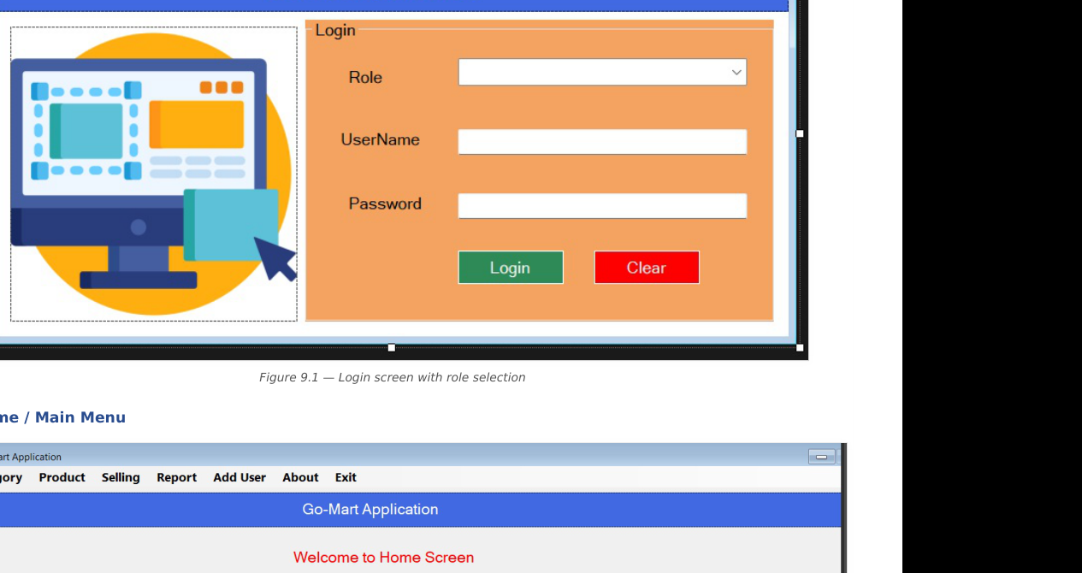
Role selection and credential entry.

Home / Main Menu
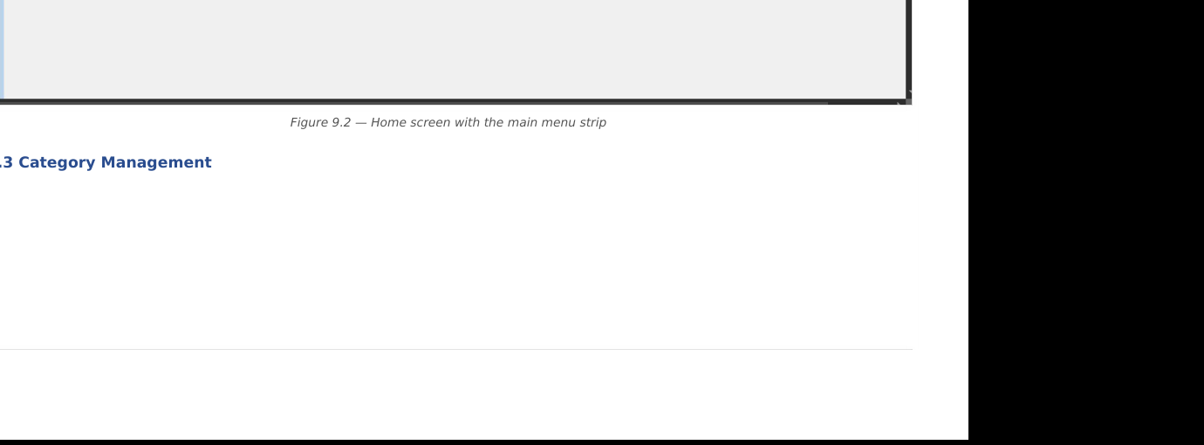
Role-based navigation after login.

Category Management
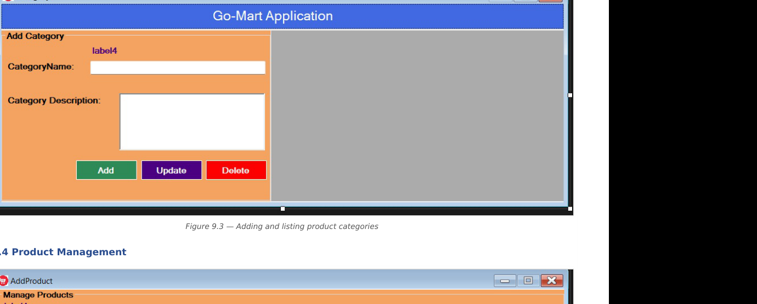
Add, update and delete product categories.

Product Management
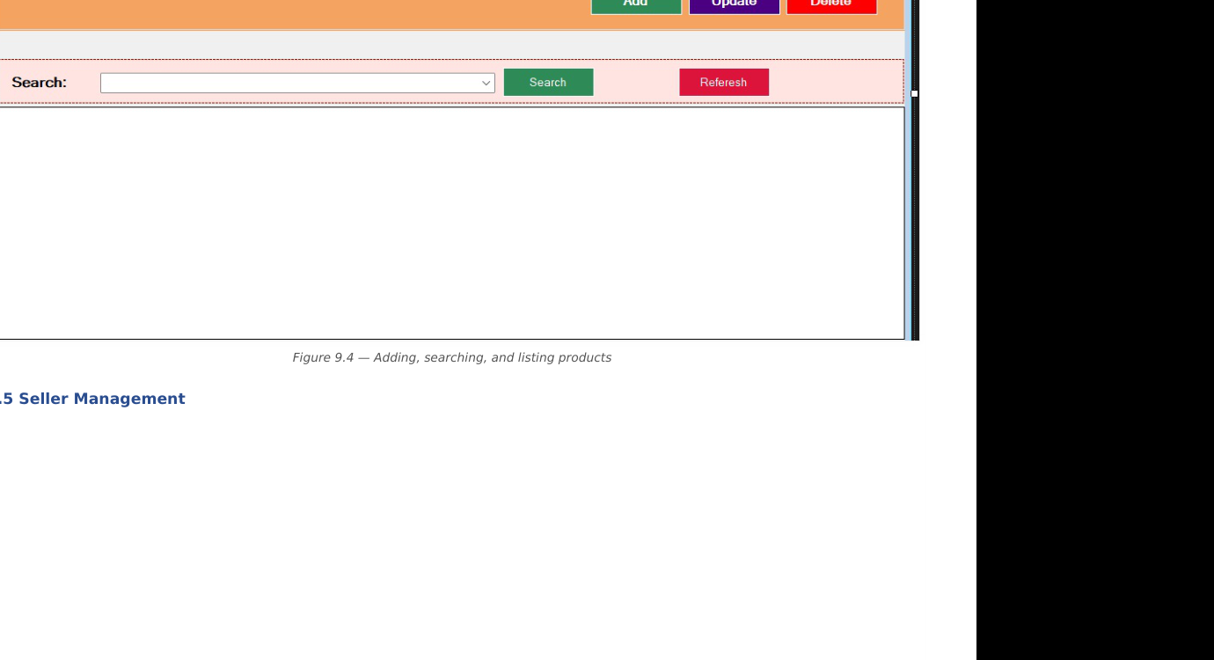
Product entry, validation, search and category filtering.

Seller Management
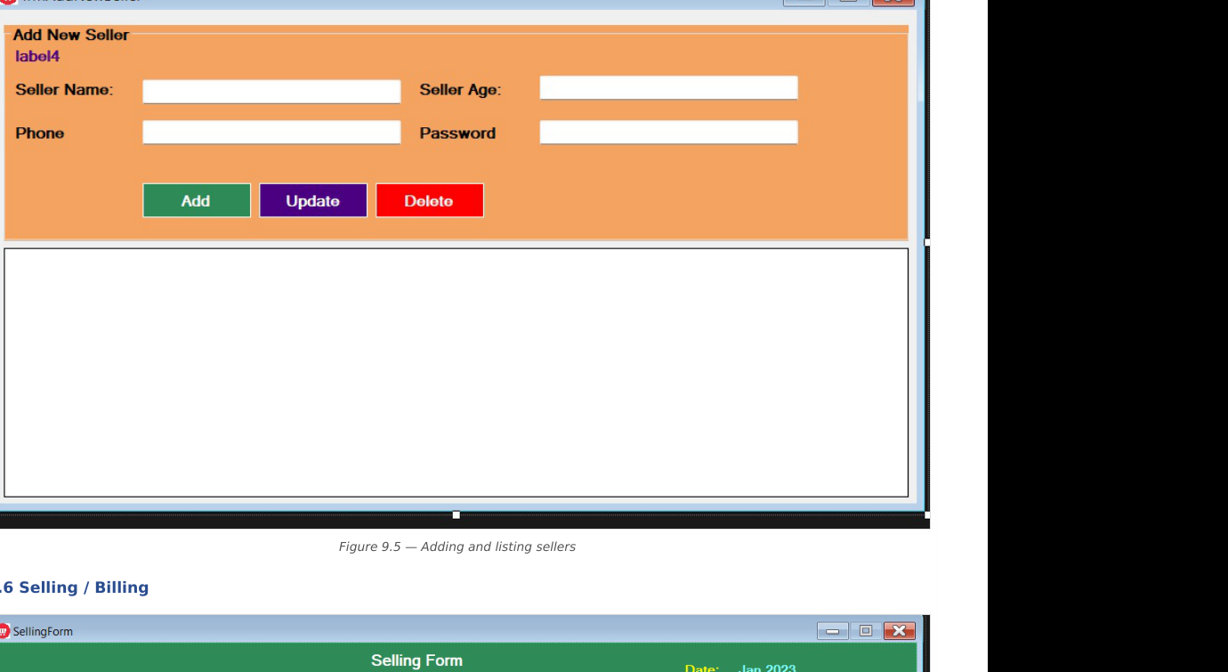
Seller account management.

Selling / Billing
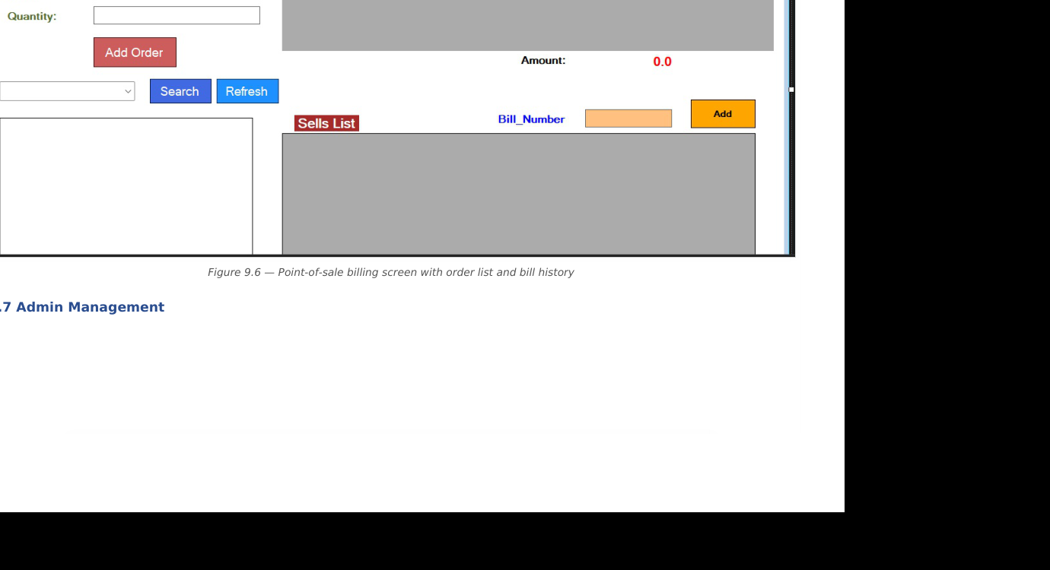
Point-of-sale order entry and bill history.

Admin Management
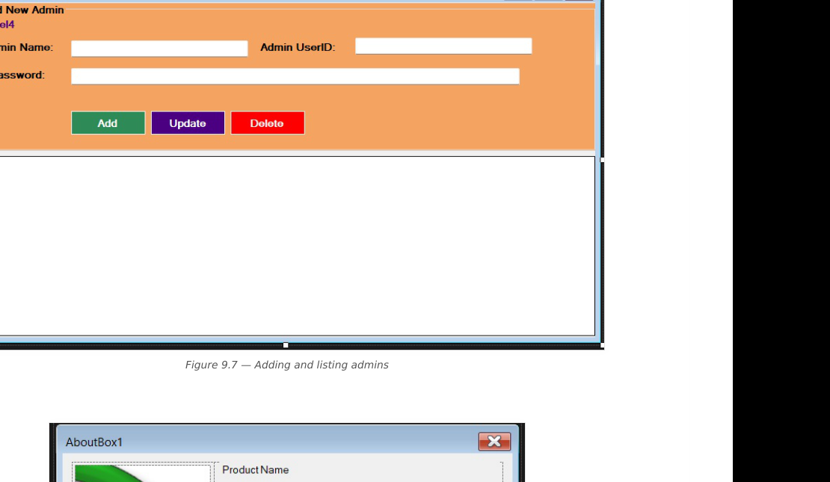
Administrator account management.

About
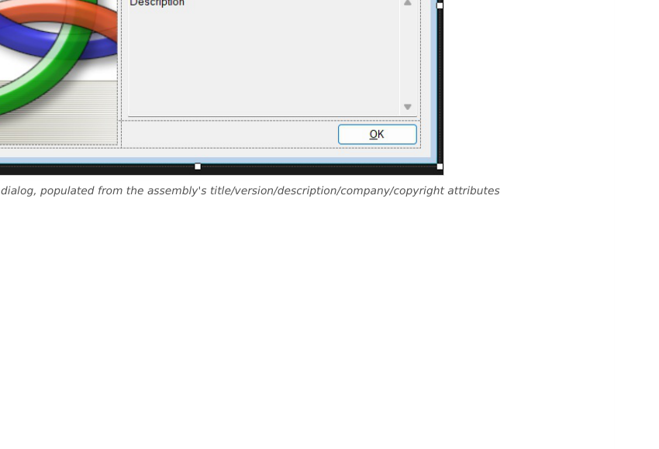
Application information dialog.

7. System Architecture & Diagrams
GoMart follows a simple layered structure: Windows Forms presentation layer → DBConnect/ADO.NET data-access layer → GoMartDB SQL Server database.

System Architecture
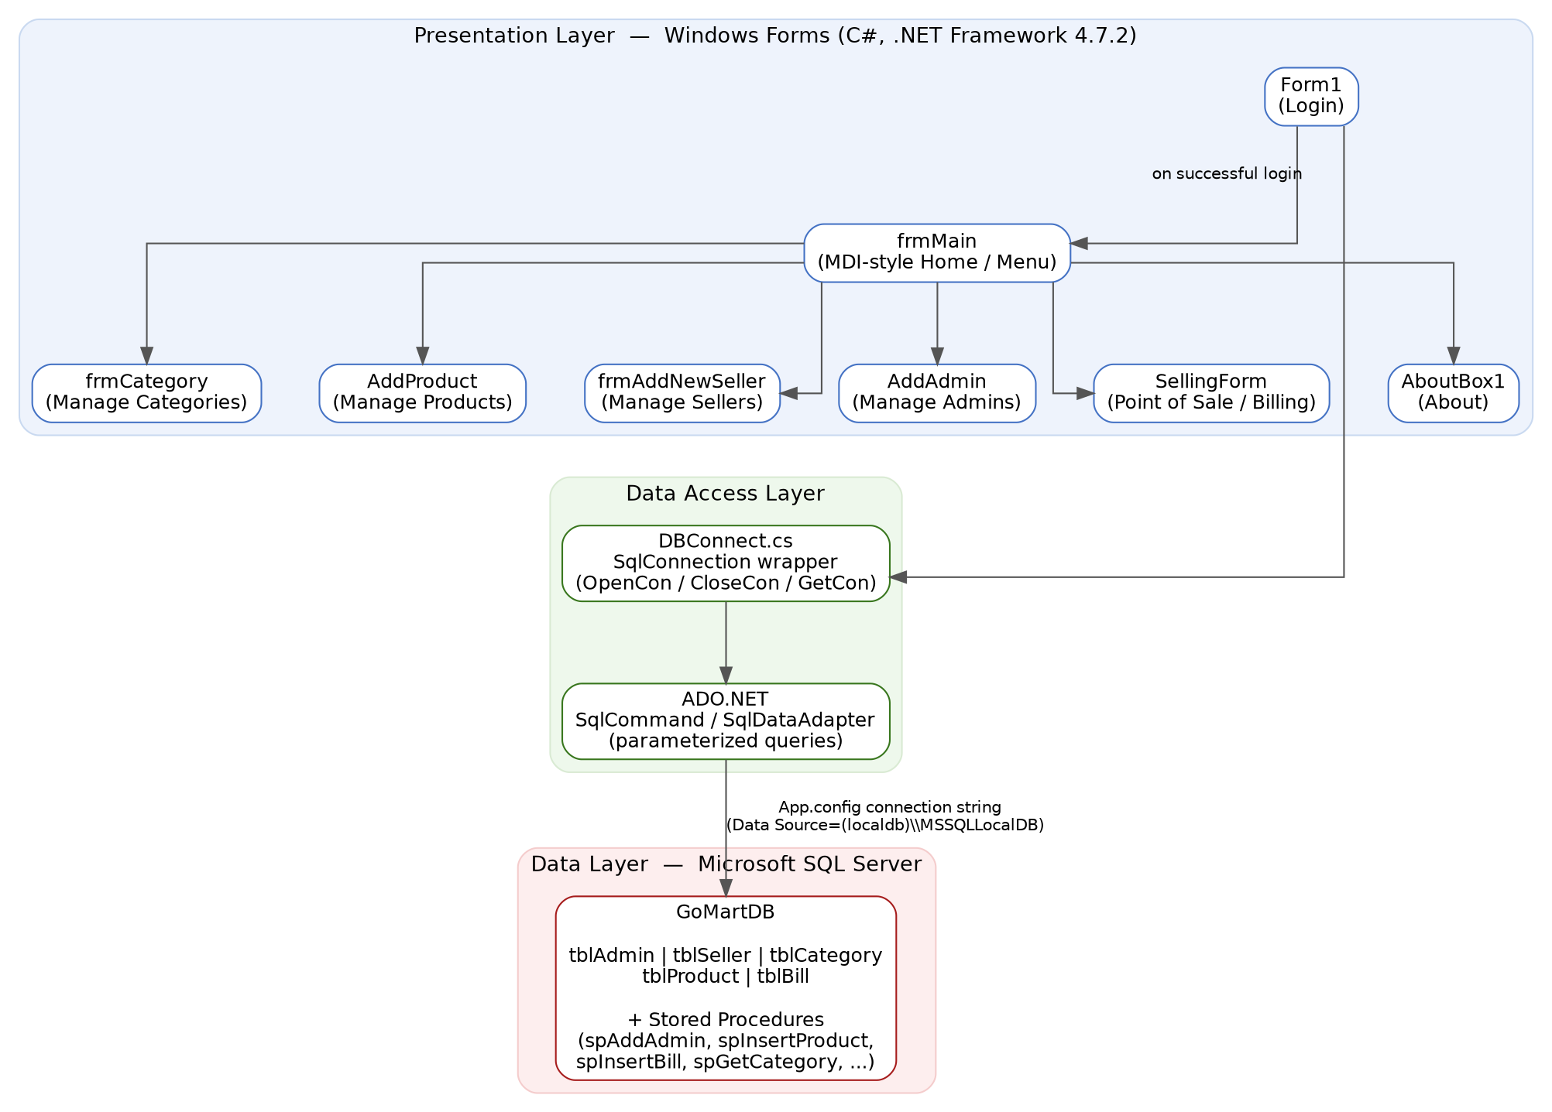
Figure 7.1 — GoMart system architecture

Login & Role-Based Access Flow
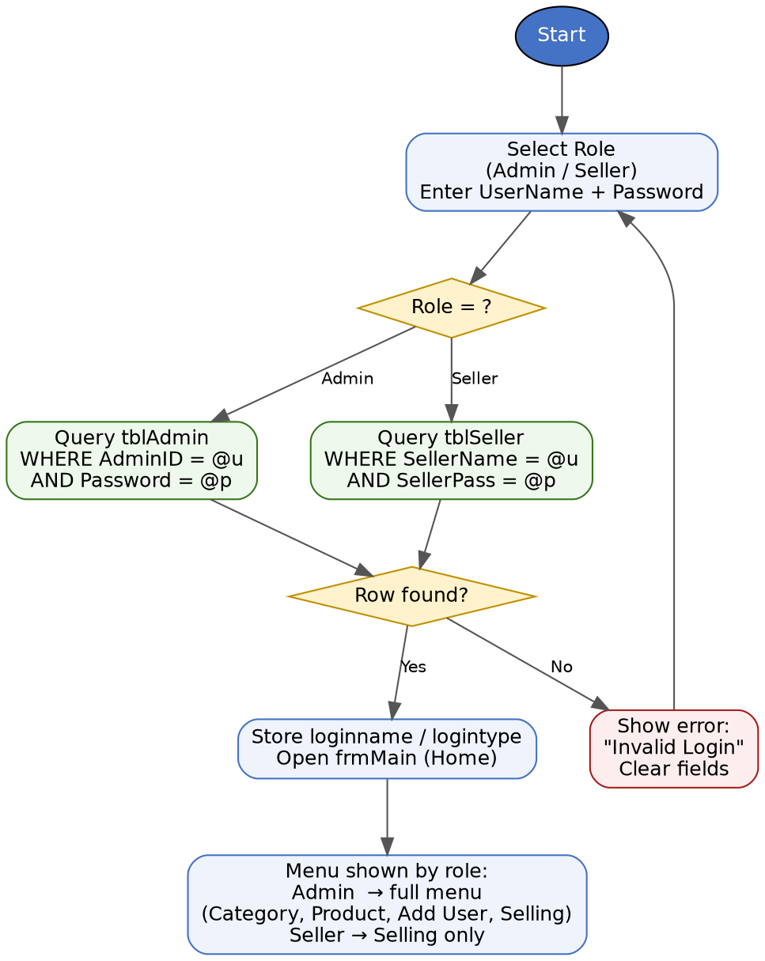
Figure 7.2 — Login and role-based access flow

Entity-Relationship Diagram
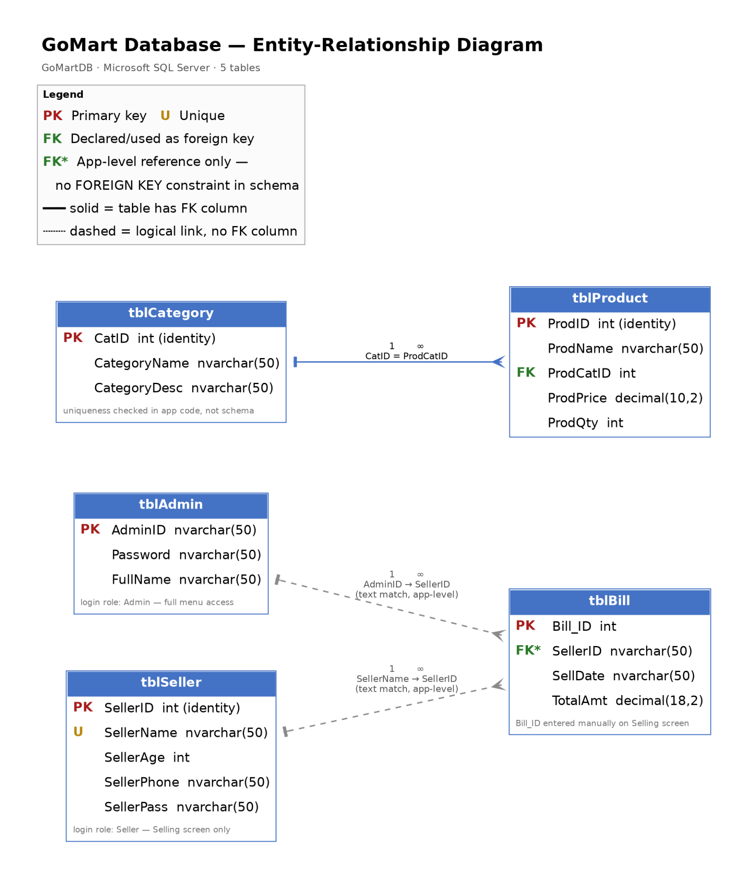
Figure 7.3 — GoMartDB entity-relationship diagram

8. Testing & Run Verification
Test Area | Verification
Login | Valid/invalid credentials, empty-field validation and role-based navigation.
Category | Create, update, delete, list and duplicate-name rejection.
Product | Validation, duplicate checking, category filtering and CRUD.
Seller/Admin | Add, update, delete and duplicate checks.
Selling | Product selection, quantity/order total, bill saving and bill history.
Database | SQL connectivity and stored-procedure/database operations.

8.1 Run Verification
- Run Database/SQL_DB/GoMartDB_SQLServer_Setup.sql in SQL Server Management Studio or Azure Data Studio.
- Alternatively import Database/GoMartDatabase.bacpac.
- Open GoMartApplication.sln in Visual Studio.
- Confirm the SQL Server connection string in App.config.
- Build and run the application.
- The supplied documentation identifies a demo Admin account: Coder / 12345.

8.2 Known Limitations
- Passwords are stored as plain text in the current project.
- The login form currently uses an inline parameterized lookup rather than the existing login stored procedures.
- Stock quantity is not automatically reduced after a sale.
- Bill number and SellDate fields are more loosely typed than ideal.

8.3 Future Scope
- Hash and salt passwords.
- Move login authentication to stored procedures.
- Automatically decrement stock and add low-stock warnings.
- Improve bill numbering, date typing and relational constraints.
- Add printable receipts, barcode support, images and richer reports.
- Consider Entity Framework or Dapper for the data layer.

9. Academic Integrity & AI Disclosure
The contribution percentage and module distribution in this report are presented as the agreed 50/50 group split. GitHub commit evidence such as exact commit counts and dates should remain consistent with the actual repository history.
If AI tools were used for drafting, explanation, debugging or documentation, the final submission should disclose that assistance according to the course/faculty requirements. AI assistance does not replace the student's responsibility to understand and explain the submitted code.

10. Declaration
I, Nawrin Parvin Adita (ID 24-56038-1), declare that this individual report represents my assigned portion of the GoMart Application and that the stated 50% contribution reflects the group-agreed distribution of the project implementation.

Student | Nawrin Parvin Adita
Student ID | 24-56038-1
Signature | Nawrin Parvin Adita
Date | 14-09-2026

Appendix — Submission Checklist
- Public GitHub repository is enabled.
- README.md is present.
- Application/source package is uploaded.
- Database and SQL files are available.
- ER, architecture and login/role diagrams are uploaded.
- GUI screenshots are uploaded.
- This individual report is uploaded under Documentation/Report/.
- The group collaborator is added through GitHub repository settings.
- Actual GitHub commit history is preserved.
- Contribution percentage matches the group agreement.

